WATCH OUT FOR !!!
AMITES
(AQUIRING MINISTERS’ TEACHING SCHOOL)

For More Enquiries
Call: 08163776464 or 07039378043

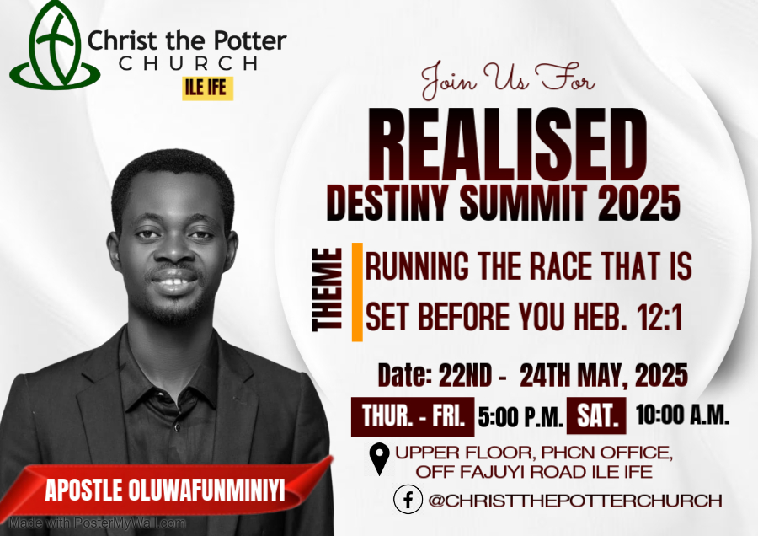

Welcome Address
Dear Beloved,
With great joy in our hearts, we welcome every one of you here present today to 2025 REALISED DESTINY SUMMIT. Our theme for this year is "RUNNING THE RACE THAT IS SET BEFORE YOU".
Heb. 12:1 “Wherefore seeing we also are compassed about with so great a cloud of witnesses, let us lay aside every weight, and the sin which doth so easily beset us, and let us run with patience the race that is set before us”.
Our journey in life and destiny is a race – a race that we must not only start but also finish well. Jer. 29:11 said God has an expected end for each of us and you must not come to another end in life and destiny different from His expected end in the race that God has set before you. He considers you a success when you attain to the end of that race and not other races in life: when you have done exactly what He called you to do. If you run another man’s race, you will not have any reward for it. The race God has set before us is not anyhow race. There are rules and laws that govern our race in life. If you do not run the race according to the rules regardless of your position, you will still be disqualified. My prayer is that God will guide us to run the race of life and destiny lawfully so that we will not be disqualified in the end in Jesus’ name. Amen
2 Tim. 2:5 “And if a man also strive for masteries, yet is he not crowned, except he strive lawfully”.
1 Cor. 9:24 “Know ye not that they which run in a race run all, but one receiveth the prize? So run, that ye may obtain.
During these three days, prepare your heart as the Lord will be taking us on a journey of deep understanding of the race He has set before us and how to run it to the profitability of His kingdom.
Stay Blessed.
Yours in Christ,
Apostle Oluwafunminiyi Olufisayo

NOTES

NOTES

MINISTER’S PROFILE

Apostle Oluwafunminiyi Olufisayo is an ordained minister of the gospel called and sent from God as a conference speaker and life trainer with an apostolic teaching and preaching mandate to teach men to walk in the reality of who Christ is. He is also passionate about seeing the order of God being established in the Church. His apostolic teaching has influenced, Inspired and transformed many lives in this Era.
He is the President of Oluwafunminiyi Samson Olufisayo Ministries and the Set Man of Christ The Potter Church.
He holds an Annual meeting tagged “GATHERING OF THE EAGLES”, a quarterly programme tagged “REALISED DESTINY SUMMIT”, a yearly programme tagged “REVELATION OF OUR SALVATION”, and also an Annual Conference for Ministers tagged: KINGDOM YOUNG MINISTERS’ CONFERENCE. He also holds a Teaching School-ACQUIRING MINISTERS’ TEACHING SCHOOL (AMITES) for those who have perceived the Call of God and those who are involve in church work. All these are set to teach and impact men to align with the ultimate counsel of God for their lives. He is happily married to Rev. Mrs. Olamide Olufisayo who also serves with him in the Ministry. They reside in Ile-Ife and they are blessed with two children, Aquila and Paul.

Schedule of Ministration
Date And Days | Morning Session | Evening Session
Thursday 22nd May |  | Apostle Oluwafunminiyi Olufisayo
Friday  23rd May |  | Apostle Oluwafunminiyi Olufisayo
Saturday 24Th May | Apostle Oluwafunminiyi Olufisayo
Programme of events
Thursday 22nd May 2025 Evening
5:pm - 5:05p.m. [5 mins.] Opening Prayers
5:05pm – 5:25 p.m. [20 mins] Shout of Praise
5:20pm – 5:40 p.m. [20 mins] Prayers and Supplication
5:40 pm – 5:50 p.m .[10 mins.] Introduction of the Minister
5:50 – 7:25 p.m. [1hr 35 mins] Word Ministration
Apostle Oluwafunminiyi Olufisayo
7:25 – 7:35 p.m. [10 mins.] Offering and announcements.
Friday 23rd May 2025 Evening
5:pm - 5:05p.m. [5 mins.] Opening Prayers
5:05pm – 5:25 p.m. [20 mins] Shout of Praise
5:20pm – 5:40 p.m. [20 mins] Prayers and Supplication
5:40 pm – 5:50 p.m .[10 mins.] Introduction of The Minister
5:50 – 7:25 p.m. [1hr 35 mins] Word Ministration
Apostle.OluwafunminiyiOlufisayo
7:25 – 7:35 p.m. [10 mins.] Offering and announcements.
Saturday 24Th May Morning
10am – 10:10a.m. [10 mins.] Opening Prayers
10:10 –10:30 a.m. [20 mins] Shout of Praise
10:30 – 10:50 a.m. [20 mins] Prayers and Supplication
10:50 – 11:00 a.m. [10 mins.] Introduction of The Minister
11:00 a.m– 1:00 p.m. [2hrs ] Word Ministration
Apostle.OluwafunminiyiOlufisayo
ANNOUNCEMENTS

Christ The Potter Church is a place you need to always be for your divine training in Life and Destiny.

WORSHIP WITH US
Sunday Sunday service:8am
Tuesday School of prayer: 5pm
Thursday Revelational Hour: 5pm

The church operates a ministry Arm “Oluwafunminiyi Samson Olufisayo Ministries”

You can connect with us ONLINE via HTTPS//MIXLR.COM/CHRIST-THE-POTTER-CHURCH or Facebook @christthepotterchurch

Visit the Media Stand to invest in your Spirit Man, “For Man shall not live by bread alone but by every word that proceeds from the mouth of God”

AVAILABLE MESSAGES

- CULTIVATING THE HABIT OF SEEKING AND RECEIVING DIVINE HELP IN THE TIME OF NEED.
- THE LAW OF GOING LITTLE FURTHER .
- UNDERSTANDING PRAYER AND THE HINDERACE THAT CHOKE THE EFFECTIVENESS.
- CONFLICT IN MARRIAGE AND HOW DEAL WITH IT.
- FAER IS NOT A CHRISTIAN VIRTUE.
- WHAT IS THE MESS HAVE YOU TRIED JESUS?
- FATHERING
- CONSECRATION
- WALKING IN THE FEAR OF GOD
- WALKING IN THE SPIRIT OF DISCERNMENT

